LAB TASK
Name: Abubakar
Roll no: 346
Section: BSAI-3D
Task 1: Calculate g, h, and f for the first three expansions
Your A* code uses the following graph and heuristic values. We can now calculate the first three expansions manually using this exact graph.

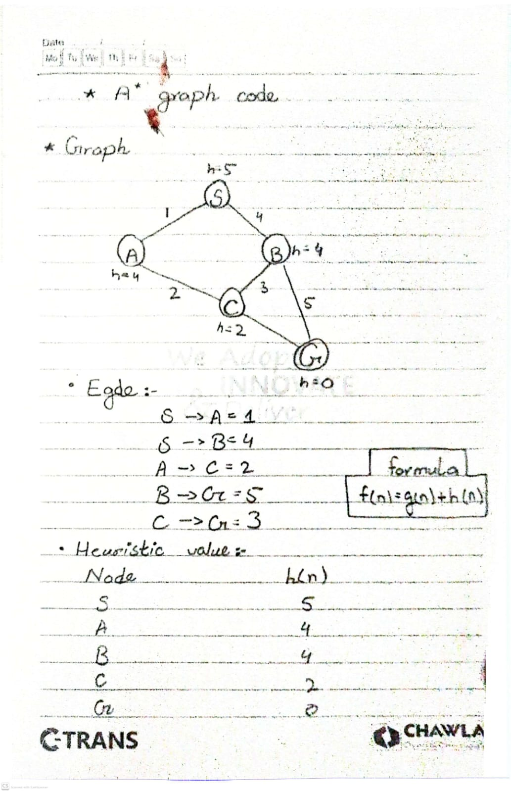
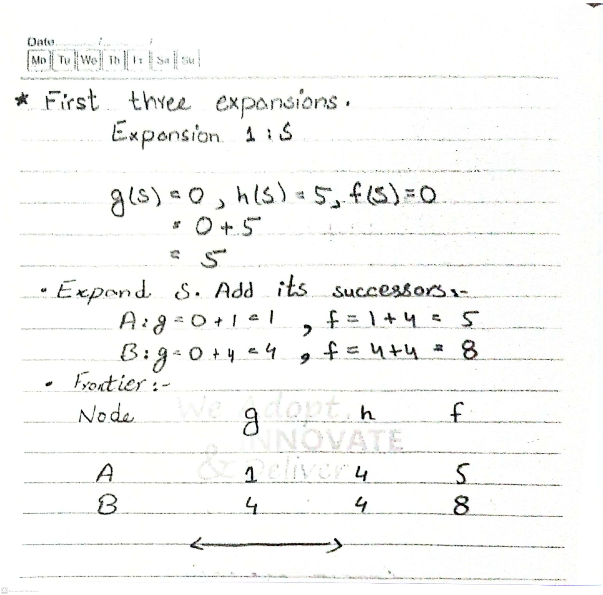

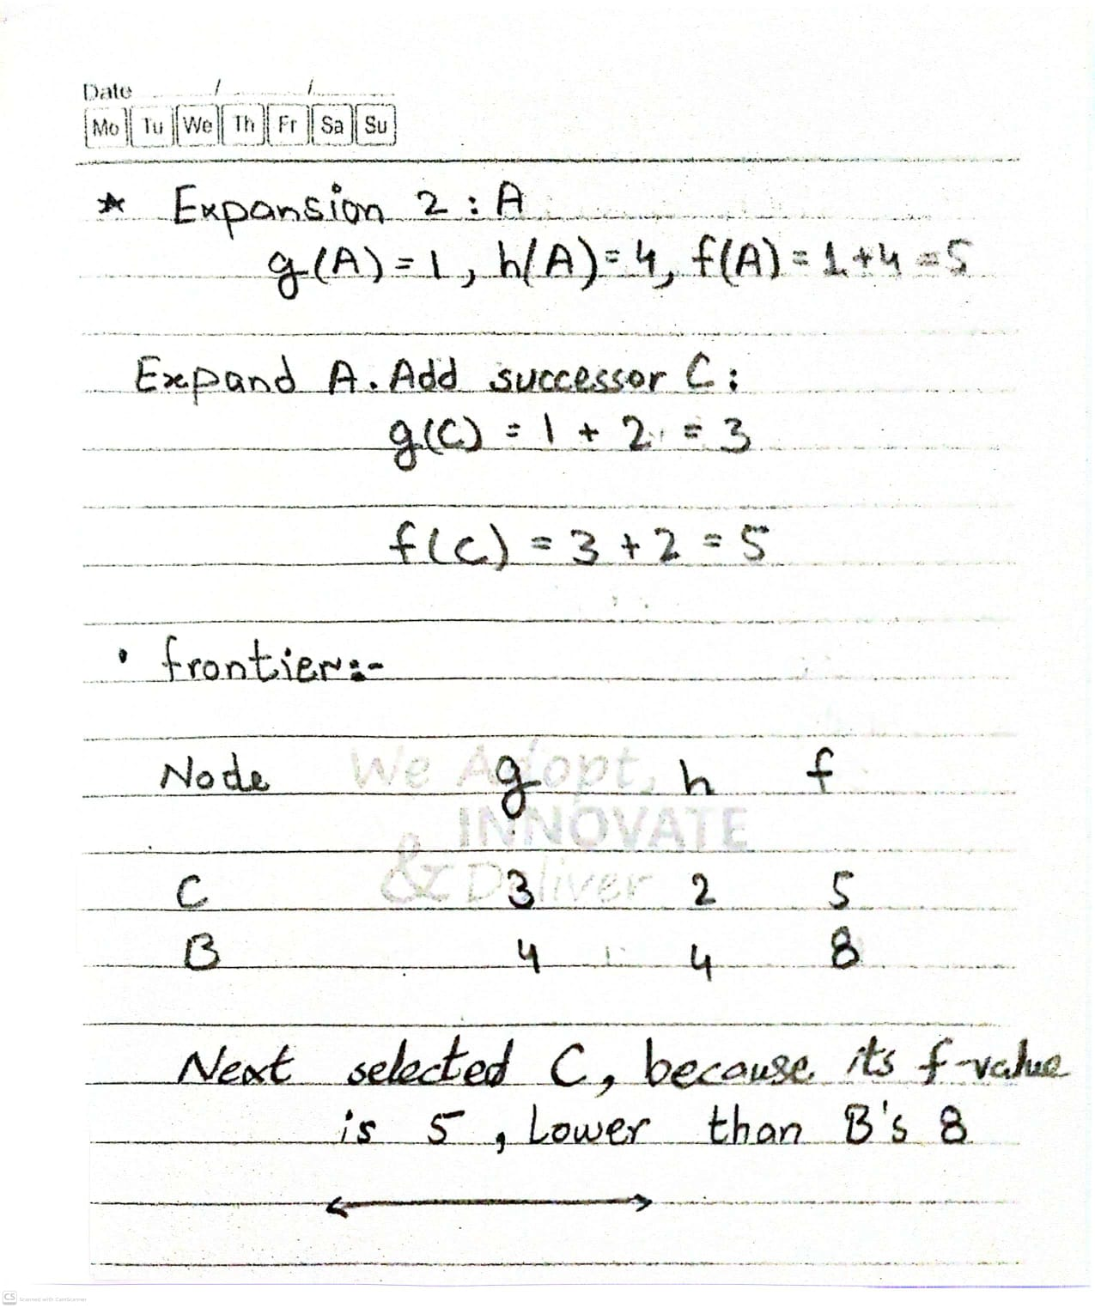

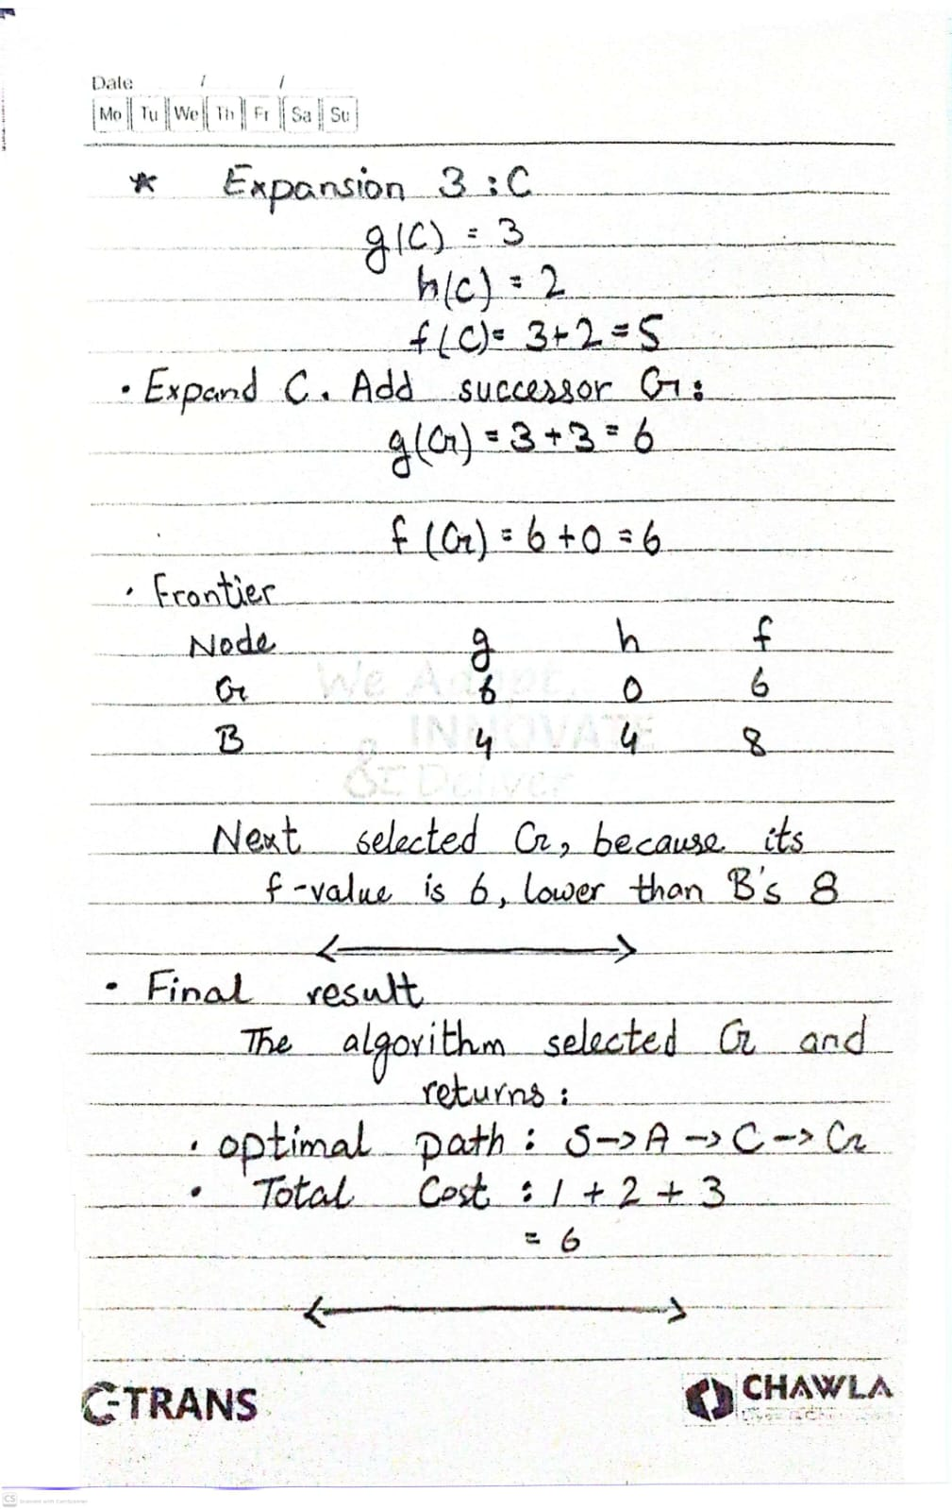
Task 2: Run A* and UCS on the same graph
We will use the exact same graph, edge weights, start node S, and goal node G from your previous code.
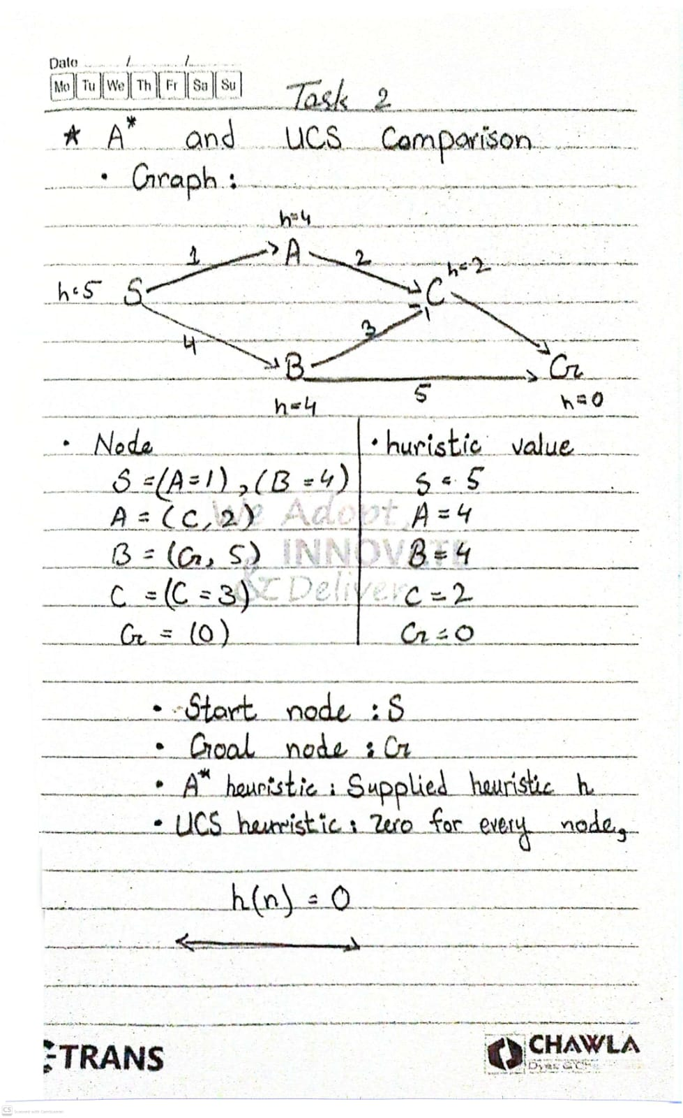
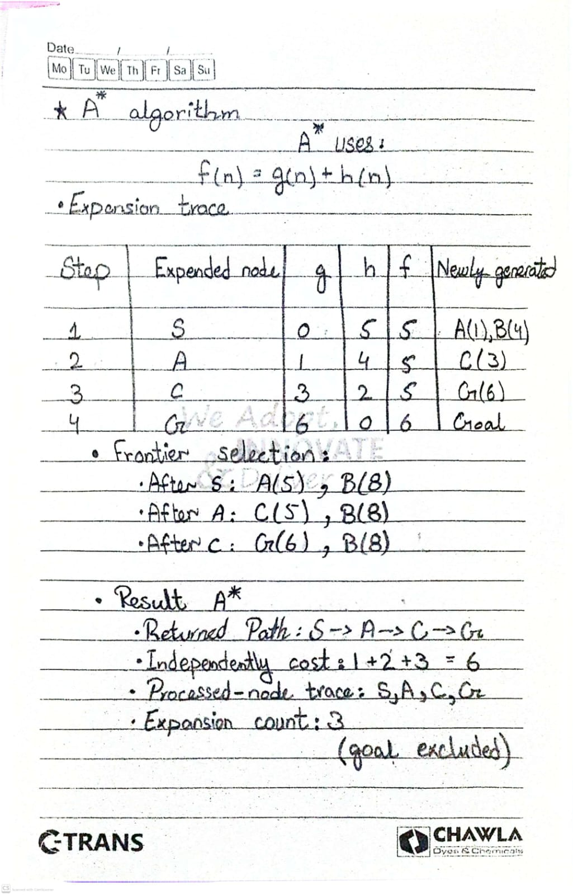
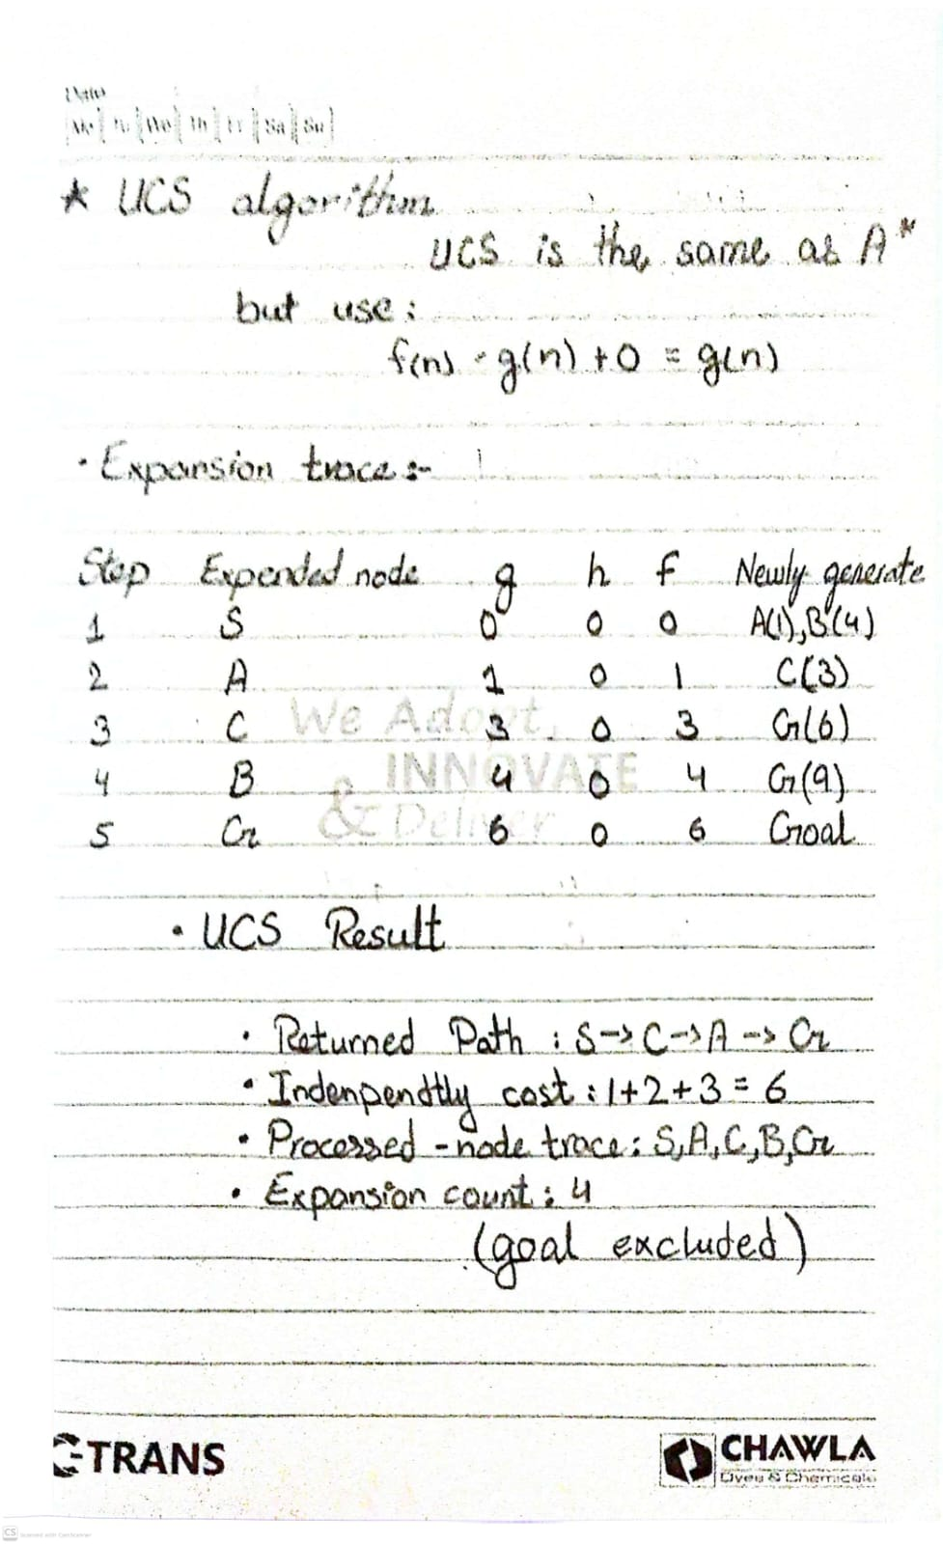
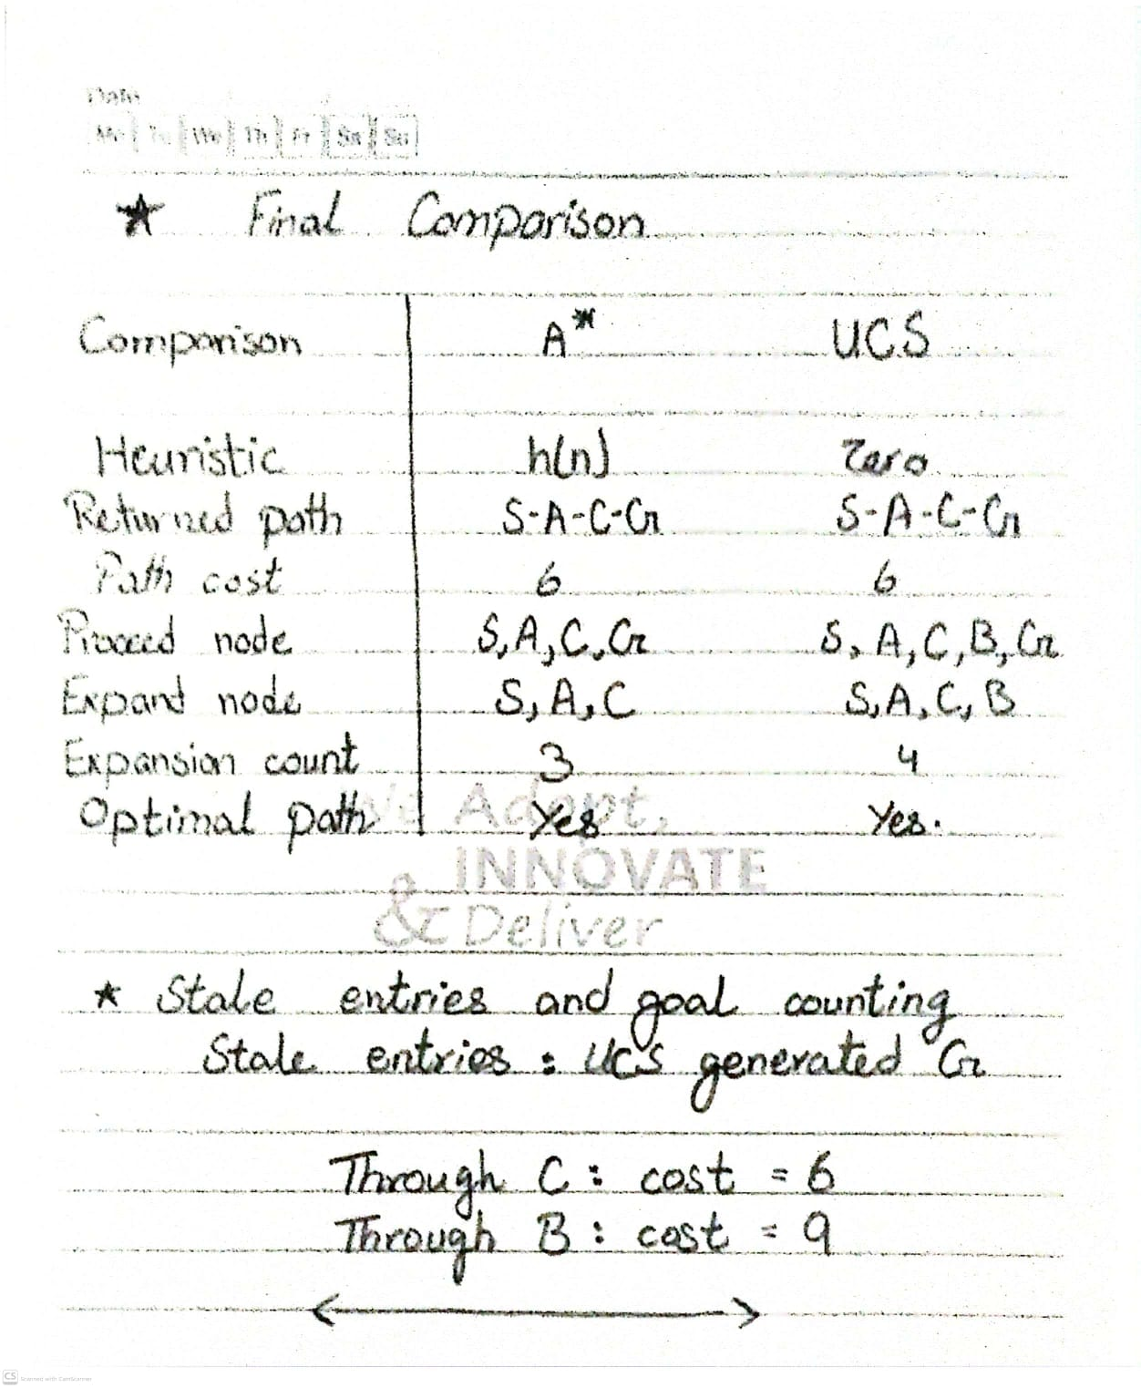

Conclusion
Both A* and UCS found the same optimal path, S → A → C → G, with total cost 6. A* expanded 3 nodes, while UCS expanded 4 nodes. A* performed one fewer expansion because its supplied heuristic guided the search toward the goal more efficiently.

Task 3: Change one heuristic to an overestimate
We will use the same weighted graph and endpoints as the previous task. Only one heuristic value will change: h(C) from 2 to 10.
The purpose is to see whether an overestimated heuristic changes A*'s returned path, cost, or expansion count
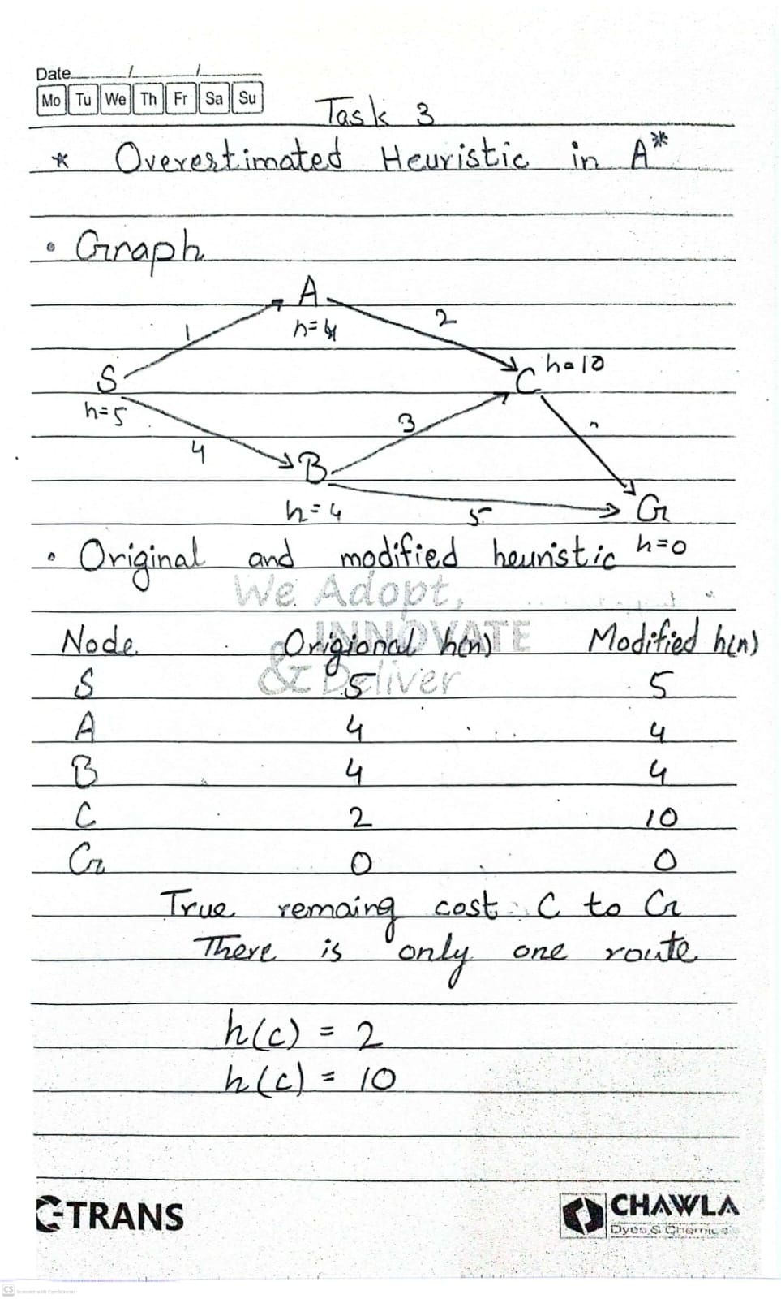
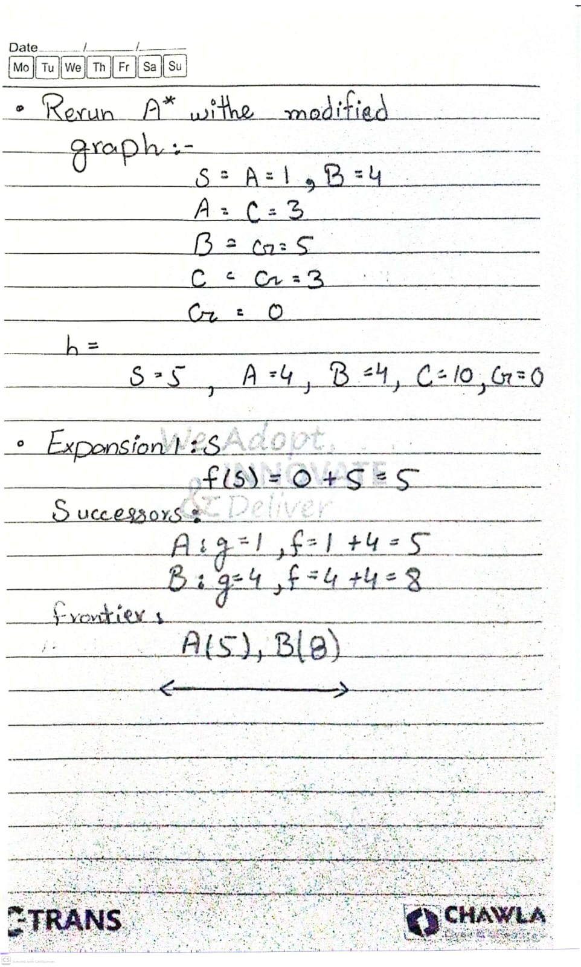
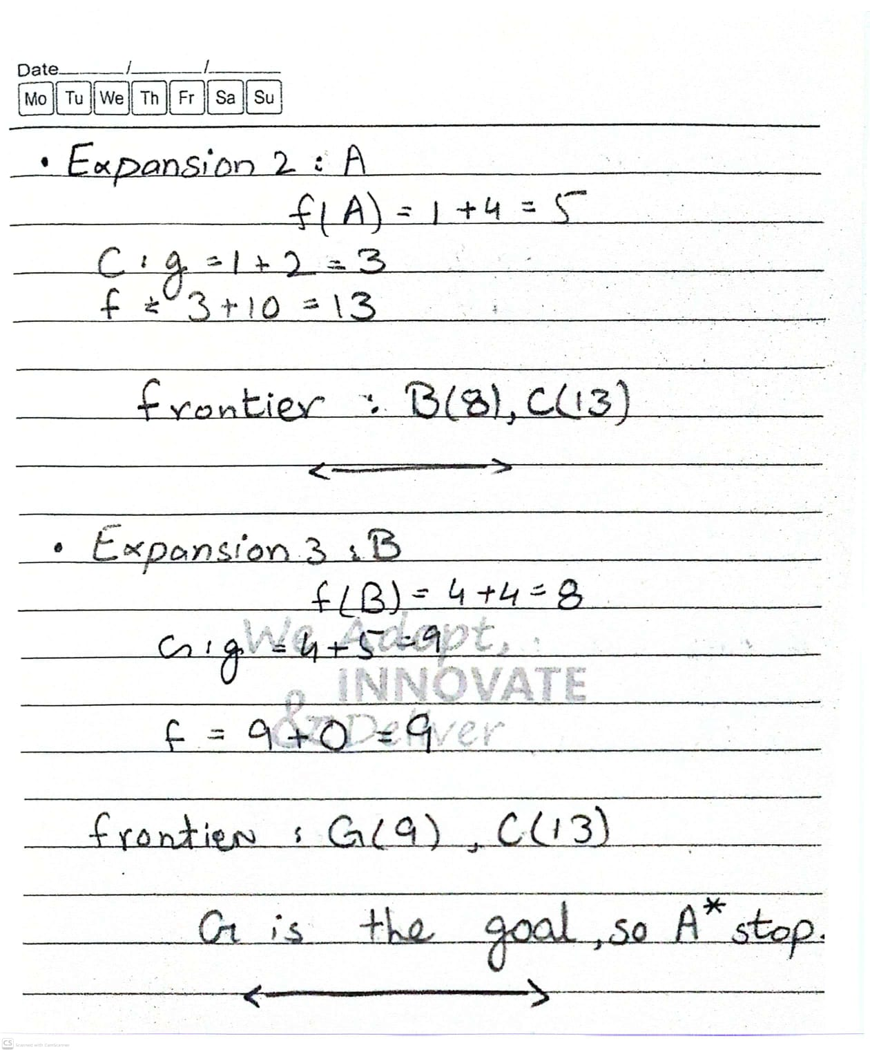

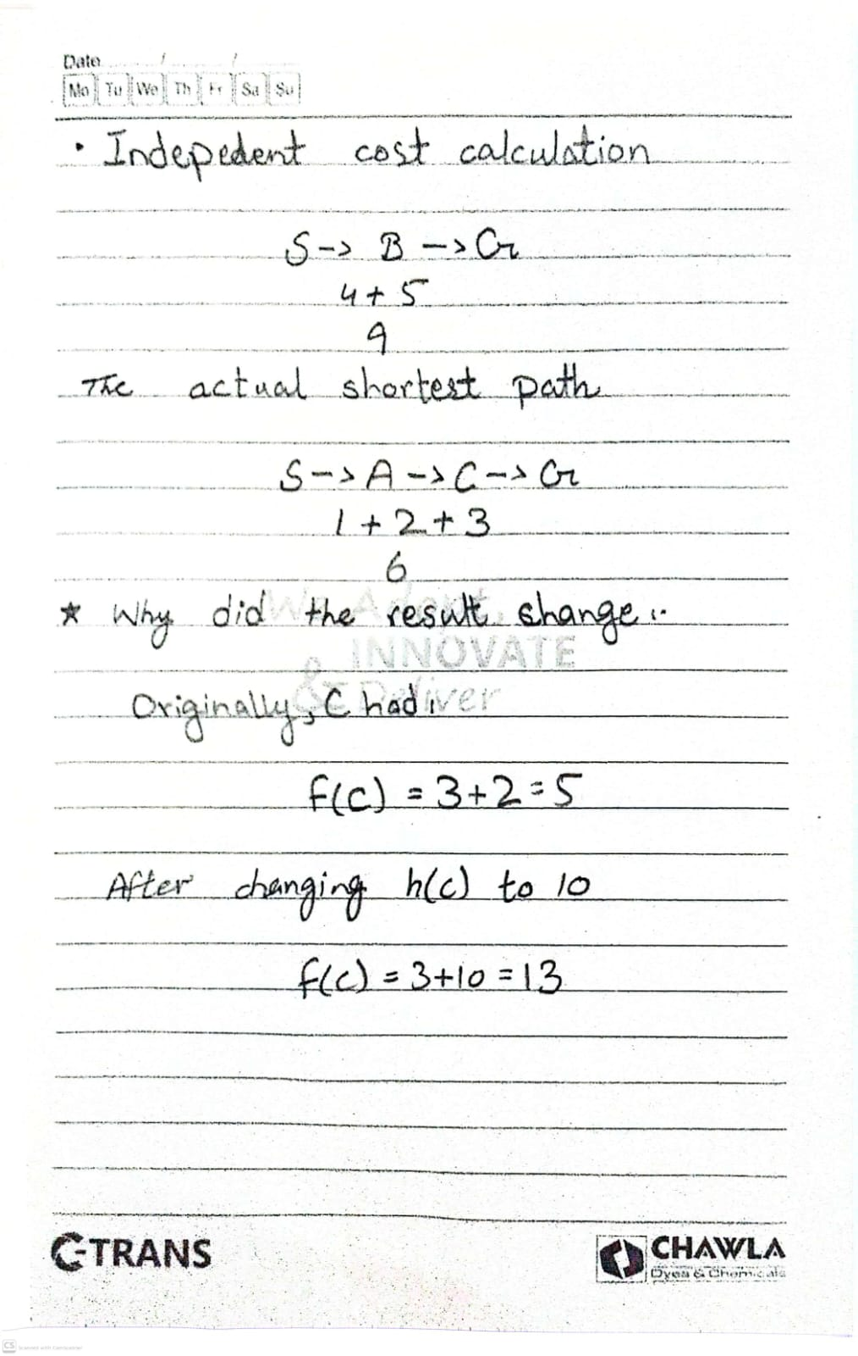
Conclusion
Changing only one heuristic value from 2 to 10 changed the returned path and increased the total cost from 6 to 9. The expansion count remained 3, but the expanded nodes changed.
An overestimated heuristic can make A* prioritize a less promising route and reach the goal before exploring a better route. Therefore, A loses its general optimality guarantee when the heuristic is not admissible*, even though some individual runs with overestimated heuristics may still return an optimal path.

